Validation Set

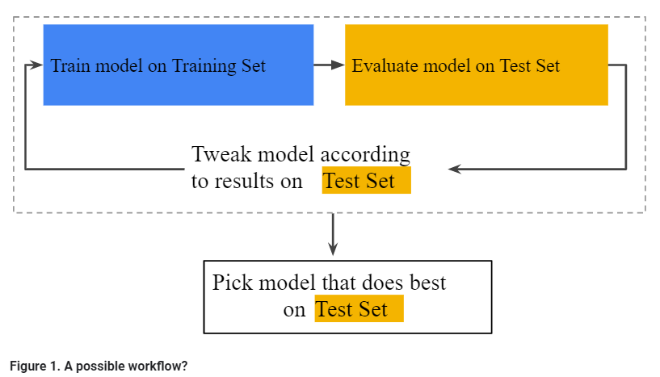

In the figure, "Tweak model" means adjusting anything about the model you can dream up—from changing the learning rate, to adding or removing features, to designing a completely new model from scratch. At the end of this workflow, you pick the model that does best on the *test set*.

Dividing the data set into two sets is a good idea, but not a panacea. You can greatly reduce your chances of overfitting by partitioning the data set into the three subsets shown in the following figure:

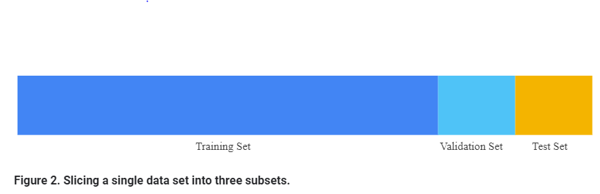

Use the **validation set** to evaluate results from the training set. Then, use the test set to double-check your evaluation after the model has "passed" the validation set. The following figure shows this new workflow:

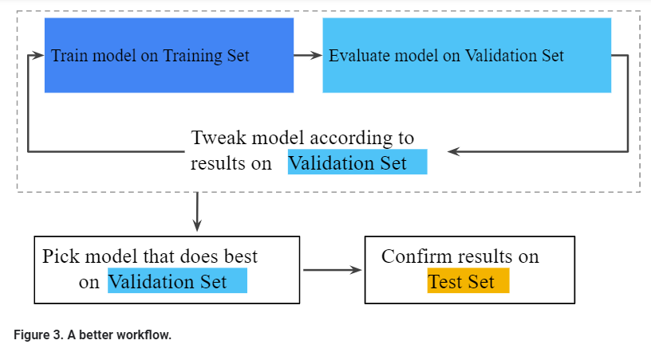

In this improved workflow:

1. Pick the model that does best on the validation set.
2. Double-check that model against the test set.

This is a better workflow because it creates fewer exposures to the test set.

**Tip**

Test sets and validation sets "wear out" with repeated use. That is, the more you use the same data to make decisions about hyperparameter settings or other model improvements, the less confidence you'll have that these results actually generalize to new, unseen data.

If possible, it's a good idea to collect more data to "refresh" the test set and validation set. Starting anew is a great reset.